**Vehicle Dipper Automatic Controller.**

Presented by

Mr. Rohit Shinde

Roll No. [TE-52]

Mr. Sahil Pawar

Roll No. [TE-38]

Mr. Om Kadhekar

Roll No. [TE-35]

Under the Guidance of,

Prof. Rekha Kadam

Department of Electronics and Telecommunication Engineering

Modern Education Society’s College of Engineering, Pune-01

Academic Year 2020-21

**ABSTRACT**

This paper presents Automatic Dipper using Light Dependent Resistor (LDR) .While driving a car in the night many drivers do not dip the head lamps of their vehicles in night while approaching. Several switching operation is used to dip the head light which may distract the concentration. One of the essential safety feature that need to be installed is automatic upper dipper control of headlight. This feature can mainly use during night drive. Human eyes are very sensitive to light .If eyes suddenly get in contact with light after darkness, cornea present in the eyes gets contract i.e. vision gets blank and require some time to recover the vision. Much time the situation comes when suddenly vehicle approaches from front with headlight in upper mode causes blindness to the eyes of the driver, during that time vehicle cover some distance and accident may occur. This temporary blindness of eyes is called as glaring effect. It is a sheer luck if person goes safely through that situation. To overcome these manual dipping problems, an automatic mechanism has made which notifies the upcoming vehicle that, their headlight is affecting our eyes and according to their response our circuit decides whether our headlight should be in dipper mode or upper mode. Construction, Working and design of circuit is briefly discussed in this paper

**INDEX**

**Chapter No. Title Page No.**

**ABSTRACT**

1. **INTRODUCTION**

* Problem Statement 7
* Need of System 7
* Advantages 7
* Applications 8

1. **LITERATURE SURVEY** 5
2. **OBJECTIVE** 10
3. **METHODOLOGY** 12
4. **CONCLUSION** 28
5. **REFERENCES 29**

**CHAPTER I**

**INTRODUCTION**

* 1. **Problem statement:**

. In current practice, to control dipper beam manually by using switch this is place on the steering column. Use of manual dipper control is not done by most of the drivers due to many reasons because the operation of dipper control switch is hundreds of times at night driving. Other reason is the driver wants to pay more attention to the steering control instead of to dipper the head light beam. Another major cause is 'ego problem', which makes each one wait till the other person initiates dipping, which may not happen .

* 1. **Need of the System:**

NEED OF PROJECT

1. Increasing in accidents
2. Decreasing the visibility during night
3. Save life

**1.3 Advantages:**

* More Convenient.
* No manual Control.
* More Reliable.
* Save life.
* More user Friendly:
* Reduceaccidents.

**1.4 Applications:**

1. Street lights
2. Railways
3. Bus
4. Private apartments

**CHAPTER II**

**LITERATURE SURVEY**

**SrinivasaChari.V1, Dr.venkatesh P.R2, Dr.PrasannaRao N.S3, Adil Ahmed S4[1]**

The author observed that the technology of pneumatics plays a major role in the field of automation and modern machine shops and space robots.. The aim is to design and develop a control system based smart electronically controlled automotive bumper activation and automatic braking system is called AUTOMATIC PNEUMATIC BUMPER AND BREAK ACTUATION BEFORE COLLISION. This project consists of IR transmitter and Receiver circuit, Control Unit, Pneumatic bumper system and pneumatic braking system. The IR sensor are used to senses the obstacle. If there is any obstacle closer to the vehicle (within 2-3 feet) the control signal is transferred to the bumper activation system and also pneumatic braking system simultaneously. The pneumatic bumper and braking system is used to product the man and vehicle. This bumper and braking system is only operate if the vehicle speed above 30-40 km per hour. This speed of vehicle is sensed by the sensor and this signal is transferred to the control unit and pneumatic bumper and braking activation system.

**Dr. P. Poongodi PPG Institute of Technology, Coimbatore, Tamil Nadu, INDIA – 641012. Mr. P. Dineshkumar, Karpagam University, Coimbatore, Tamil Nadu, INDIA – 641021**.[**2]**

In this paper, the need for safety of vehicles by reducing the impact of crash by applying a smooth or partial braking with the help PIC 16F877a micro controller is proposed. The driver’s risk of sensing the object from a particular distance and not able to notice within the certain limit such conditions are occures while designing this work. Once the similar situation will faced to acceleration of the vehicle will be directly controlled without any disturbing the safe throttle (actuation mechanism) of the vehicle, the designed machine itself takes the control of acceleration pedal if the brake is not applied within the predetermined distance.

**Takahiro Wada “A Deceleration control method of automobile for collision avoidance based on driver perceptual risk” IEEE international Conference on Smart Robots and Systems, Oct 4881-4886 [3]**

The author observed that the to reduce rear-end crash of automobiles, it is important to judge necessity of deceleration assistance as earlier as possible and initiate the assistance naturally. On the other hand, we have derived a mathematical model of driver's perceptual risk of proximity in car following situation and successfully derived driver deceleration model to describe deceleration patterns and break initiation timing of expert driver. In this paper, an smart braking system for accident avoidance will be proposed based on the formulated brake profile model and brake initiation model of expert driver to realize smooth, secure brake assistance naturally. In addition, experimental results using a driving simulator will show validity of the proposed system based on subjective evaluation.

**Matthew L. Brumbelow David S. ZUBY Institute of Highway Safety United States Paper No. 09-0257 “IMPACT AND INJURY PATTERNS IN FRONTAL CRASHES OF VEHICLES WITH GOOD RATINGS FOR FRONTAL CRASH PROTECTION”[4]**

There are two consumer evaluation programs of vehicle frontal crashworthiness in the United States. The National Highway of Traffic Safety Administration (NHTSA) gives occupant protection ratings of 1 to 5 stars for the drivers based on vehicle performance in a full-width test into a rigid wall at 35 mi/h (56 km/h). The Insurance Institute for Highway Safety (IIHS) assigns vehicle ratings of good, acceptable, marginal, or poor based on performance in a 40 mi/h (64 km/h) test in which 40% of the vehicle front impacts a deformable barrier. These programs were introduced, structural and restraint system designs have very good improved substantially, and high test performance now is treated as a de facto standard. Among vehicles rated in the IIHS frontal offset test between January 2005 and May 2008, 85% received good ratings, with the rest receiving the second highest rating of acceptable. In this NHTSA’s frontal Car Assessment Program (NCAP), 95% of model year 2008 vehicles achieved a 4- or 5-star rating for both the driver and right front passenger.

**CHAPTER III**

**OBJECTIVE**

We aim to create a system that:

* to design low cost syste
* to detect upcoming vehicle using ldr sensor
* to automatic change mode of headlight from upper to dipper
* to reverse the mode of headlight as soon as upcoming vehicle passes away

**CHAPTER IV**

**METHODOLOGY**

**BLOCK DIAGRAM**

ATMEGA 16

LDR sensor

POWER SUPPLY

As shown in above block diagram we present an headlight control system for smart vehicle . here input energy source is selected using LDR sensor.

The relay is been used as the connector between upper and dipper.

Upper is connected to NC pin of relay,while dipper is connected to NO pin of relay and battery is a connected to COMMON pin of relay.

Working is as shown below

normal condition

Solar panel

NC C

battery

NO

dynamo

Vehicle detecting state

NC

Solar panel

battery

dynamo

C

NO

HEADLIGHT OF VEHICLE

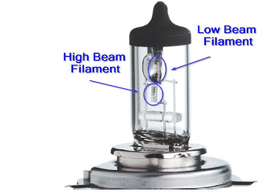

Fig-2: Double filament headlamp

shown in fig.2. Here one filament is used for upper beam and another for dipper beam. While driving at night, the headlight is the only source of vision and it require essentially from evening 6.00pm to morning 6.00am. Driver can switch the headlight from upper beam to dipper beam or vice versa using manual switch

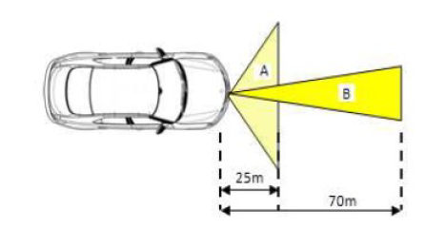

3: Range of dipper beam (A) and upper beam (B) of a vehicle

Upper beam covers the larger distance up to 70m and dipper beam covers the small distance up to 25m and at both the time intensity of head light is different. Fig.3 gives the clear idea about how much distance covered by headlight for upper beam and dipper beam [4].



Hardware used

1. Atmega 16
2. Ldr sensor
3. Relay
4. Power supply

Circuit diagaram

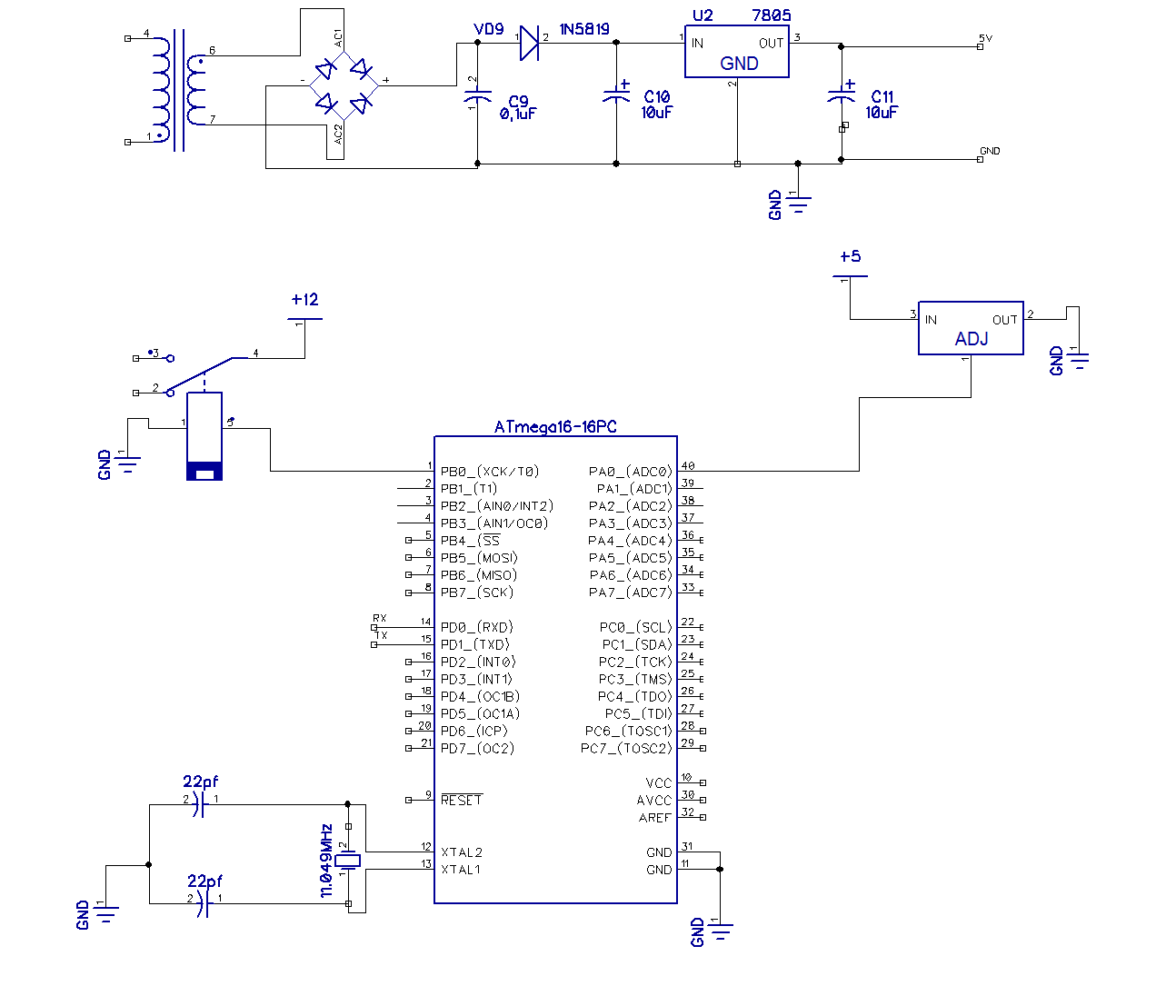

Pcb layout

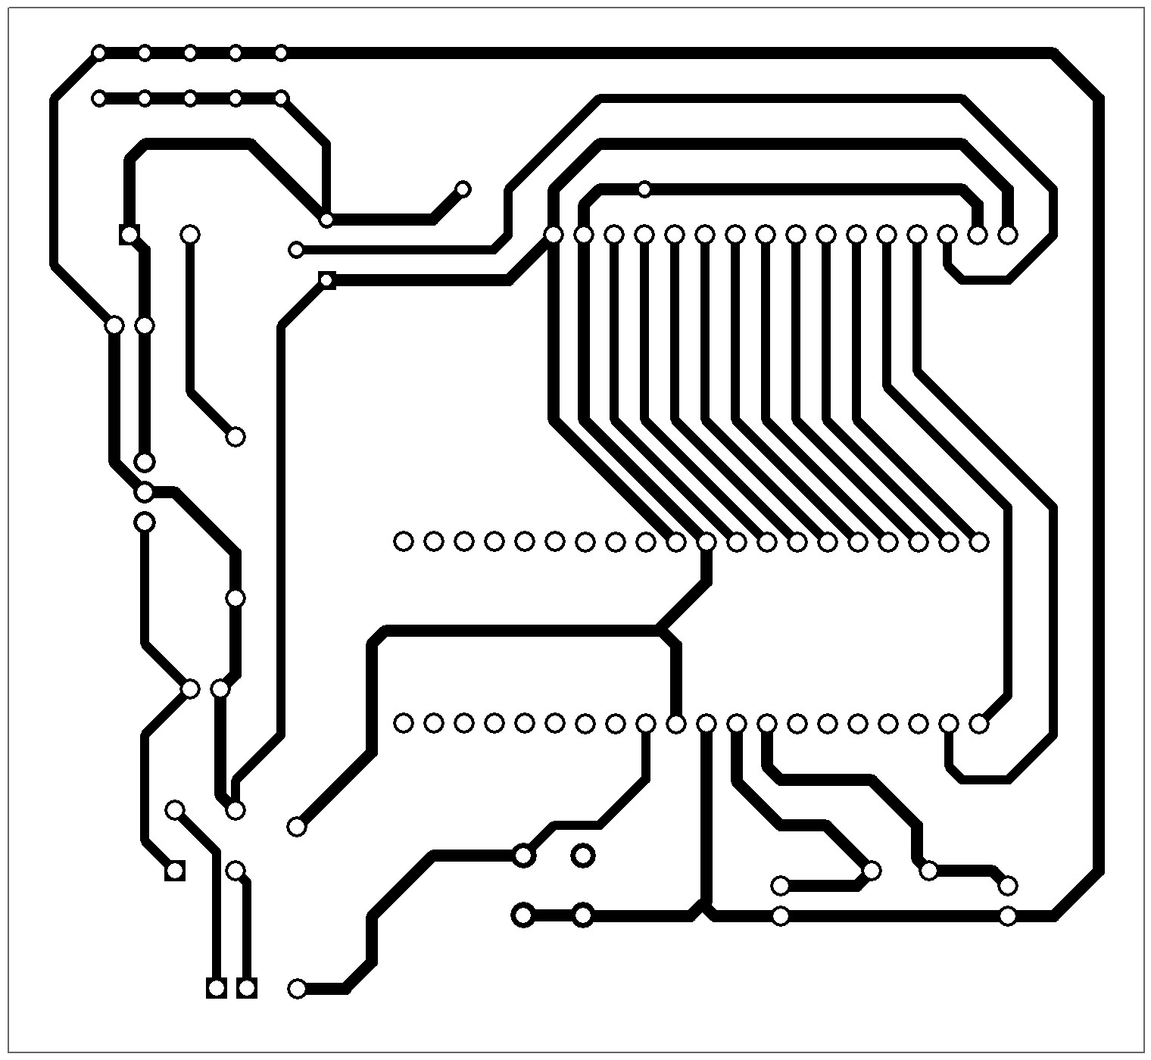

ATMEGA16 Controller

ATmega16 is an 8-bit high performance microcontroller of Atmel’s Mega [AVR](http://www.engineersgarage.com/articles/avr-microcontroller) family with low power consumption. Atmega16 is based on enhanced RISC (Reduced Instruction Set Computing, Know more about [RISC and CISC Architecture](http://www.engineersgarage.com/articles/risc-and-cisc-architecture)) architecture with 131 powerful instructions. Most of the instructions execute in one machine cycle. Atmega16 can work on a maximum frequency of 16MHz.ATmega16 has 16 KB programmable flash memory, static RAM of 1 KB and EEPROM of 512 Bytes. The endurance cycle of flash memory and EEPROM is 10,000 and 100,000, respectively. ATmega16 is a 40 pin microcontroller. There are 32 I/O (input/output) lines which are divided into four 8-bit ports designated as PORTA, PORTB, PORTC and PORTD.ATmega16 has various in-built peripherals like [USART](http://www.engineersgarage.com/embedded/avr-microcontroller-projects/serial-communication-atmega16-usart), [ADC](http://www.engineersgarage.com/embedded/avr-microcontroller-projects/adc-circuit), [Analog Comparator](http://www.engineersgarage.com/embedded/avr-microcontroller-projects/analog-comparator-circuit), [SPI](http://www.engineersgarage.com/embedded/avr-microcontroller-projects/spi-serial-peripheral-interface-tutorial-circuit), [JTAG](http://www.engineersgarage.com/embedded/avr-microcontroller-projects/disable-jtag-port) etc. Each I/O pin has an alternative task related to in-built peripherals

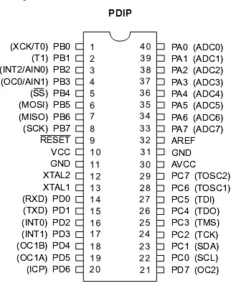

•High-performance, Low-power AVR® 8-bit Microcontroller

• Advanced RISC Architecture

• High Endurance Non-volatile Memory segments

– 16K Bytes of In-System Self-programmable Flash program memory

– 512 Bytes EEPROM

– 1K Byte Internal SRAM

• On-chip Boot Program

• Programming of Flash, EEPROM, Fuses, and Lock Bits through the JTAG Interface

• Peripheral Feature

•Two 8-bit Timer/Counters with Separate Prescalers and Compare Modes

• Real Time Counter with Separate Oscillator

•Four PWM Channels

• 8-channel, 10-bit ADC

•Programmable Serial USART

• Master/Slave SPI Serial Interface

• Programmable Watchdog Timer with Separate On-chip Oscillator

• On-chip Analog Comparator

•Power-on Reset and Programmable Brown-out Detection

•Six Sleep Modes: Idle, ADC Noise Reduction, Power-save, Power-down, Standby

and Extended Standby

• I/O and Packages

– 32 Programmable I/O Lines

– 40-pin PDIP, 44-lead TQFP, and 44-pad QFN/MLF

• Operating Voltages

– 4.5 - 5.5V for ATmega16

• Speed Grades

– 0 - 16 MHz for ATmega16

**Why we choose AVR ?**

* **Power consumption:** Power consumption is lower than PIC.
* **UART:** High baud rate are possible from low clock frequencies than PIC.
* **Interrupts:** in AVR vectored interrupts are more efficient than PIC.
* **Instruction set/architecture:** Add with carry, and compare with carry simplify multiple precision arithmetic. good range of conditional branches.
* **Clocks:** Wide range of RC oscillator speed than PIC.

Relay:- A relay is an [electrically](https://en.wikipedia.org/wiki/Electric) operated [switch](https://en.wikipedia.org/wiki/Switch). Many relays use an [electromagnet](https://en.wikipedia.org/wiki/Electromagnet) to mechanically operate a switch, but other operating principles are also used, such as [solid-state relays](https://en.wikipedia.org/wiki/Solid-state_relay). Relays are used where it is necessary to control a circuit by a separate low-power signal, or where several circuits must be controlled by one signal. The first relays were used in long distance [telegraph](https://en.wikipedia.org/wiki/Electrical_telegraph) circuits as amplifiers: they repeated the signal coming in from one circuit and re-transmitted it on another circuit. Relays were used extensively in telephone exchanges and early computers to perform logical operations.

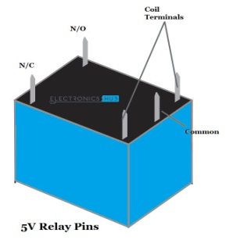

**. LCD Power Sources:**

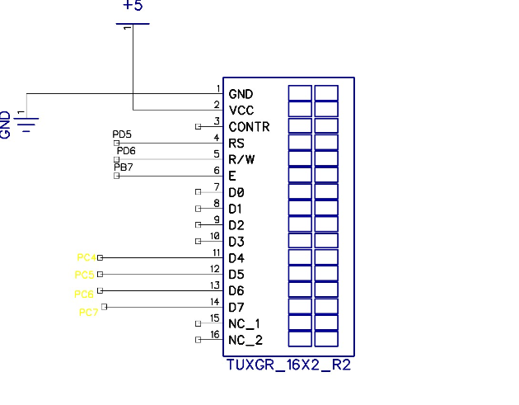

**Figure 6: Pin Diagram of LCD**

* LCD has 2 Power Sources
* 1. VCC and GND are at 1 and 2 NO. Pins of LCD. Used to drive the LCD 3mA current consumption.
* 2. VCC and GND is at 15 and 16 NO. pins of LCD used to drive the backlight of LCD 100 mA current
* Total current consumption = 3mA + 100mA = 103 mA
* So, in order to reduce the current requirement we are connecting a 330 ohm resistance in series with the backlight pin VCC. This reduces the current consumption (100mA / 330ohm =0.303 mA).

**Therefore new total current consumption = 0.303Ma**

| **Pin No.** | **Symbol** | **Function** |
| --- | --- | --- |
| 1 | GND | GROUND |
| 2 | VCC | + 5 V |
| 3 | CONTRAST | GND |
| 4 | E | ENABLE |
| 5 | RS | REGISTER SELECT |
| 6 | R/W | READ WRITE |
| 7 | DB0 | DATA LINE |
| 8 | DB1 | DATA LINE |
| 9 | DB2 | DATA LINE |
| 10 | DB3 | DATA LINE |
| 11 | DB4 | DATA LINE |
| 12 | DB5 | DATA LINE |
| 13 | DB6 | DATA LINE |
| 14 | DB7 | DATA LINE |
| 15 | VCC | + 5 V |
| 16 | GND | GND |

**Table 1: LCD Pin description**

**9.4. Power supply**

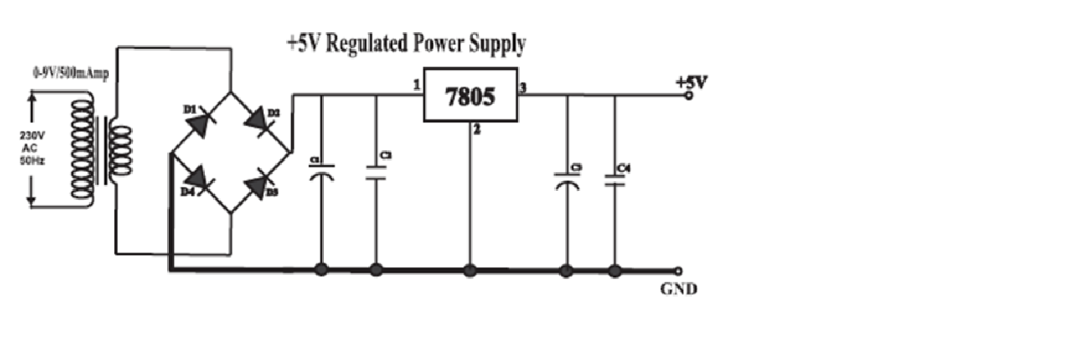

**Figure 7: Circuit Diagram-Power Supply**

* The basic step in the designing of any system is to design the power supply required for that system. The steps involved in the designing of the power supply are as follows,

1) Determine the total current that the system sinks from the supply.

2) Determine the voltage rating required for the different components.

* The bridge rectifier and capacitor i/p filter produce an unregulated DC voltage which is applied at the I/P of 7805.
* The minimum dropout voltage is 2v for IC 7805, the voltage applied at the input terminal should be at least 7 volts .
* C1 (1000 µf / 65v)is the filter capacitor .
* C2,C4 (0.1uF ceramic),C3 (220uF/25V electrolyte capacitor) is to be connected across the regulator to improve the transient response of the regulator.
* Assuming the drop out voltage to be 2 volts, the minimum DV voltage across the capacitor C1 should be equal to 7volts (at least).

**9.4.1. Power supply component design**

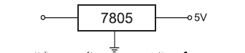

**9.4.1.1. Transformer Design**

We require +5V o/p. The drop-out voltage of regulator is 2V (As per datasheet).

Vdc = 5+2 = 7V

So at the regulator input minimum 7V should be applied.

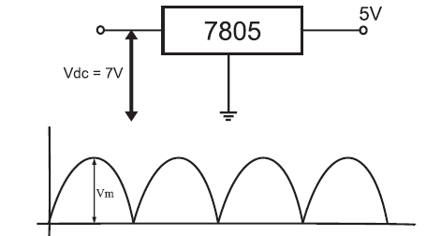

According to formula,

**Vdc= 2Vm / pi.**

Assuming there is no Ripple Capacior

Hence From

**Vm = Vdc . pi / 2**

= 7 x 3.14 / 2

= 10.99V

**Vm = 10.99V**

During one cycle, two diode are conducting, hence

Drop of voltage of one diode = 0.7V

Drop of voltage of two diode = 1.4V

**Vim = Vm + 1.4V**

Vim = 10.99 + 1.4

**Vim= 12.39V**

**Vrms = Vim / Sqrt (2)**

=12.39 / Sqrt (2)

**Vrms = 8.76V**

**Vim = 12.39V**

**Vrms = 8.76V**

**So we select transformer of 9V**

Similarly **Im = Idc x pi / 2.**

Im = 400m x 3.14 / 2

**Im = 628mA**

**Irms = Im / Sqrt (2)**

= 628m / Sqrt (2)

= 444.06 mA

**Irms = 444.06mA**

So we select transformer with current rating of 500mA.

Considering voltage and current transformer

we take **Transformer - 0-9V / 500mA Step down transformer**

**9.4.1.2. Rectifier Design**

PIV of diode = Vm = 12.39 V

Im = 628 mAmp

So we select bridge IC of 1 Ampere rating.

**9.4.1.3. Filter capacitor Design**

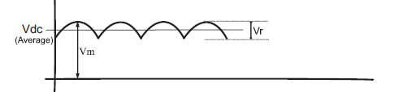

**R = Vdc / Idc**

= 7 / 400m

= 17.5 Ohms

**Vr = 2 (Vim - Vdc)**

= 2(12.39 - 7)

**Vr = 10.78V**

**C = Vdc / (F x R x Vr)**

= 7 / (100x17.5x10.78)

C =371.05uF

So for safe working we select capacitor 0f 1000uF

**C = 1000uF / 35V**

**C1 -** 1000uF/35V - Electrolytic Capacitor

**C2, C4 -**0.1uF Ceramic Capacitor

**C3 -**220uF/25V Electrolytic Capacitor

**Why 11.0592 MHz?**

Serial data communication needs often dictate the frequency of the oscillator because of the requirement that internal counters must divide the basic clock rate to yield **standard communication baud rates**. If the basic clock frequency is not divisible without a reminder, then the resulting communication is not standard.

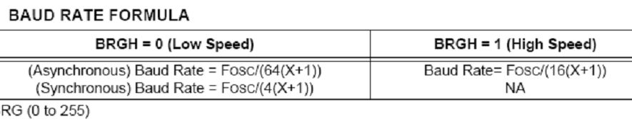

**Table 2: BAUD RATE FORMULA**

Here we keep

SPBRG = 143; for 4800 baud rate and 71 for 9600 baud rate

BRGH = 1; high speed

Therefore 11.0592 MHz / 16 (143 +1);

11.0592 MHz / 16(144);

* 1. / 2304;

1. s/sec (a standard communication baud rate)

**Ldr sensor**

A **photoresistor** or **light-dependent resistor** (**LDR**) or **photocell** is a light-controlled variable [resistor](https://en.wikipedia.org/wiki/Resistor). The [resistance](https://en.wikipedia.org/wiki/Electrical_resistance) of a photoresistor decreases with increasing incident light intensity; in other words, it exhibits [photoconductivity](https://en.wikipedia.org/wiki/Photoconductivity). A photoresistor can be applied in light-sensitive detector circuits, and light- and dark-activated switching circuits.

A photoresistor is made of a high resistance [semiconductor](https://en.wikipedia.org/wiki/Semiconductor). In the dark, a photoresistor can have a resistance as high as several megohms (MΩ), while in the light, a photoresistor can have a resistance as low as a few hundred ohms. If incident light on a photoresistor exceeds a certain [frequency](https://en.wikipedia.org/wiki/Frequency), [photons](https://en.wikipedia.org/wiki/Photon) absorbed by the semiconductor give bound [electrons](https://en.wikipedia.org/wiki/Electron) enough energy to jump into the [conduction band](https://en.wikipedia.org/wiki/Conduction_band). The resulting free electrons (and their [hole](https://en.wikipedia.org/wiki/Electron_hole) partners) conduct electricity, thereby lowering [resistance](https://en.wikipedia.org/wiki/Electrical_resistance). The resistance range and sensitivity of a photoresistor can substantially differ among dissimilar devices. Moreover, unique photoresistors may react substantially differently to photons within certain wavelength bands.

A photoelectric device can be either intrinsic or extrinsic. An intrinsic semiconductor has its own [charge carriers](https://en.wikipedia.org/wiki/Charge_carrier) and is not an efficient semiconductor, for example, silicon. In intrinsic devices the only available electrons are in the [valence band](https://en.wikipedia.org/wiki/Valence_band), and hence the photon must have enough energy to excite the electron across the entire [bandgap](https://en.wikipedia.org/wiki/Bandgap). Extrinsic devices have impurities, also called [dopants](https://en.wikipedia.org/wiki/Dopants), added whose ground state energy is closer to the conduction band; since the electrons do not have as far to jump, lower energy photons (that is, longer wavelengths and lower frequencies) are sufficient to trigger the device. If a sample of silicon has some of its atoms replaced by phosphorus atoms (impurities), there will be extra electrons available for conduction.

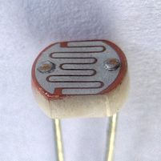

**3.3 Software specifications / requirements**

1. DIPTRACE
2. ISP PROG
3. AVR STUDIO

**3.4 Flow chart**

START

INIT HW & SW

READ SENSOR VALUE

IF L>T1

SWITCH TO DIPPER

NO YES

SWITCH TO UPPER

END

**CHAPTER V**

**CONCLUSION**

Automatic dipper provides better safety at night time and drivers can drive comfortably and reach their destination safely. There are two modes provided viz. automatic and manual mode. While driving in the cities there are light everywhere which can affect the working of the device at that time the mode can shift to manual mode to avoid flickering of the headlight. When both the vehicles were fitted with the “Automatic Dipper” then both the vehicles dip the headlight beam of each other efficiently. Main components helps to run the circuit are easily available and

are also cheap. The circuit is compatible with any vehicle and doesn’t require any other supply; it can efficiently work on battery fitted in the vehicles. Therefore the installation of this safety system in each vehicle give safety at night driving, increase comfort level of driver and decrease the road accidents.

**CHAPTER VI**

**REFERENCES**

[1] Ramakant Gayakwad, “Op-Amps & Linear Integrat Circuits”, 4th ed. PHI Learning Private Limited, New Delhi, pp. 400-405.

[2] D. Roy Choudhary, “Linear Integrated Circuits”, 4th ed. New Age International Publishers, pp. 311-315.

[3] Sushil Kumar Choudhary, “Electronic Head Lamp Glare Management System for Automobile Applications”, International Journal of Research in Advent Technology, Vol.2, No.5, May 2014, pp. 402- 416.

[4] Muralikrishnan.R, “Automatic Headlight Dimmer A Prototype for Vehicles”, International Journal of Research in Engineering and Technology, Vol.3, Issue: 02, Feb-2014, pp. 85-90.

[5] www.autodipper.com/concept.html/

[6] www.circuitstoday.com/555-timer/

[7] http://en.wikipedia.org/wiki/555_timer_IC/

[8] www.electronicsproject.org/automatic-dipper-forvechical/

[9] https://learn.sparkfun.com/tutorials/switchbasics/polesand-

throws-open-and-closed

[10] https://en.wikipedia.org/wiki/Photoresistor